EXPERIMENT NO: 22
Implementation of Bird Flying Identification System Using Prolog.
AIM:
To write and execute a Prolog program to identify whether a particular bird can fly or cannot fly using facts and rules.
PROCEDURE:
- Open SWISH Prolog software.
- Enter the Prolog program in the editor.
- Define different birds as facts.
- Identify flying and non-flying birds.
- Create rules to check whether a particular bird can fly or cannot fly.
- Click the Run button to load the program.
- Enter the required query in the Query box.
- Click Run and observe the output.
PROGRAM:
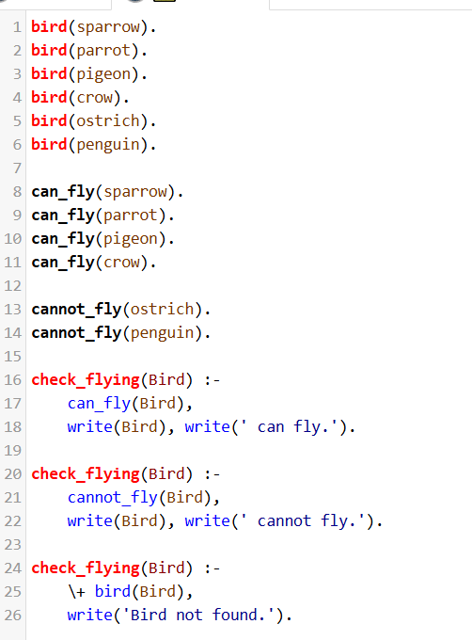

OUTPUT:
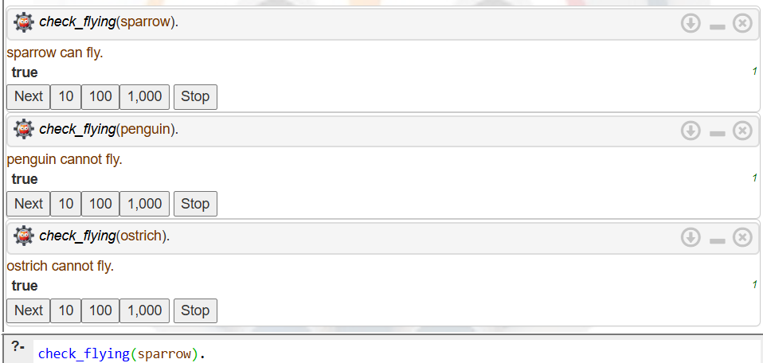

RESULT:
Thus, the Prolog program to identify whether a particular bird can fly or cannot fly was successfully implemented and executed using facts and rules.

